Jongensgat6 Dxpedition

24th August to 27th August 2009

by Gary Deacon

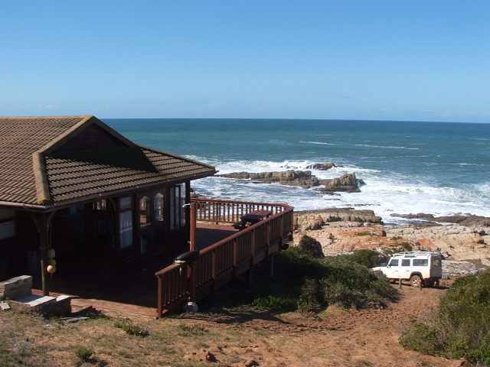
Another enjoyable dxpedition to Jongensgat with fellow dxers Vince Stevens and John Plimmer (with John's wife Dawn and friend Willie) produced some interesting dx.

After arriving safely in Vince's 4x4 on Monday afternoon (24th August), I set up and directed the 220 metre BOG towards Argentina / over the shoulder towards Japan.

Conditions

Strong signals from Japan and the Philippines were noted during the evenings. Argentina dominated across the band during the early hours with many stations still present from that part of the world after 0900 UTC with the sun well up in the sky !

Falkland Island Broadcasting Service

The highlight of the dxpedition was the reception of Falkland Island Broadcasting Service on 530 kHz. So far as I am aware, this is the first time that The Falkland Islands has been received on mediumwave in South Africa (eQSL below).

The Loggings – Asia and Far East

Freq = kHz Time = UTC

549 VIETNAM VoV2 My Van 1618 w ann by YL presenter – fair 24/8/09

630 PHILIPPINES DZMM Bulacan (Presumed) 1617 w ann – fair 24/8/09

711 VIETNAM VoV1 Thoi Long 1624 w ann by OM presenter – fair 24/8/09

720 INDIA AIR Chennai 1708 w mx – fair 25/8/09

792 CHINA Unidentified 1616 w ann – fair 25/8/09

801 INDIA AIR Jabalpur 1615 in EE – poor 25/8/09

936 INDIA AIR Tiruchirapalli 1542 in EE – fair 25/8/09

936 CHINA Unidentified 1618 w ads and ann – fair 25/8/09

945 INDIA AIR Sambalour 1555 in EE – fair 24/8/09

954 PHILIPPINES DZEM Bulacan 1552 w EE id, National Anthem and s/off 24/8/09

972 INDIA AIR Cuttack 1533 w EE news – fair 25/8/09

999 INDONESIA RRI Jakarta 1620 w talkback – fair 25/8/09

1026 PHILIPPINES DZAR Quezon City 1558 w “Sonshine Radio” id – poor 25/8/09

1053 JAPAN JOAR Nagoya 1806 w “Lucy In The Sky With Diamonds” - poor 24/8/09

1062 PHILIPPINES DZEC Pasig 1529 w easy listening mx – fair 25/8/09

1080 CHINA CRI Kunming 1627 in EE – fair 24/8/09

1089 CHINA Unidentified 1627 w talkback – very good 24/8/09

1098 TAIWAN RTI Kouhu (Presumed) 1540 w ann – fair 25/8/09

1134 CHINA CNR1 1712 w mx – very good 24/8/09

1143 TAIWAN Taiwan Area Fishery Broadcasting Station Penghu 1712 w ann by YL – good 24/8/09

1242 VIETNAM Vov Thoi Long in EE 1610 – very good 24/8/09

1242 JAPAN JOLF Tokyo 1805 w “Lucy In The Sky With Diamonds” - fair 24/8/09

1278 JAPAN JOFR Fukuoka 1625 w RKB id – good 24/8/09

1269 CHINA Voice of Russia 1759 w ann incl internet address – fair 25/8/09

1314 PHILIPPINES DWXI Paranaque 1547 w talkback – good 24/8/09

1314 JAPAN JOUF Osaka 1904 w ann // 1332 kHz – poor 25/8/09

1323 CHINA CRI 1621 in EE – fair 24/8/09

1332 JAPAN JOSF Nagoya 1600 w jingle and “I Was Kaizer Bill's Batman” by Whistling Jack Smith- good 24/8/09

1377 CHINA CNR1 Zhengzhou w ann 1614 – good 24/8/09

1395 CHINA Unidentified 1558 w piano music – good 24/8/09

1413 JAPAN JOIF Fukuoka 1840 w annimated announcements and music – good 24/8/09

1467 THAILAND So. Wor. Thor. Chiang Mai 1700 w National Anthem – fair 25/8/09

1512 PHILIPPINES DYAB Cebu City 1547 w talkback – good 25/8/09

1521 TAIWAN CBS / RTI Changchih 1620 w ann by YL – fair 24/8/09

1530 PHILIPPINES DZME Balacan 1605 w id ann – very good 25/8/09

1566 AIR Nagpur 1530 w news in EE – fair 25/8/09

1566 KOREA HLAZ Jeju w discussion – fair 25/8/09

1593 CHINA CNR1 1610 – excellent 24/8/09

South America / Caribbean / USA

530 FALKLAND ISLANDS FIBS Port Stanley 0536 w BBC WS Relay Network Africa also at 0600 with time check for “6 o'clock”, the World Today programme lineup and news. Heard during our local dawn/sunrise with Radio Botswana's usually strong signal no longer an issue around that time – fair 24/8/09. South African First.

530 ARGENTINA AM 530 La Voz de las Madres Buenos Aires 0515 w mention of
Buenos Aires – fair 25/8/09

550 URUGUAY Radio Colonia Colonia 0530 w id – fair 25/8/09

590 ARGENTINA Radio Continental Buenos Aires 2347 w id – fair 25/8/09

610 URUGUAY Radio Rural Montevideo 2306 w mx – fair 25/8/09

630 ARGENTINA Radio Rivadavia (tentative) 0512 w mention of Buenos Aires – fair 27/8/09

700 ARGENTINA Radio Cordoba 0457 in SS w ann incl mention of “Central Cordoba” – very good 27/8/09

710 ARGENTINA Radio Diez 0450 w mention of “Black Berry” and id – excellent 25/8/09

730 PARAGUAY Radio Cardinal Asuncion 0522 w id and music – fair 25/8/09

750 VENEZUELA RCR Caracas 0336 w id – fair 26/8/09

760 ARGENTINA Radio Atlantica Mar del Plata 2250 w id – fair 25/8/09

770 URUGUAY Radio Oriental Montevideo 0534 w id – very good 25/8/09

790 ARGENTINA Radio Mitre Buenos Aires 0440 w ads incl “Victoria Plaza”, Radio Mitre id and “Yakety Sax” by Boots Randolph – good 25/8/09

870 ARGENTINA Radio Nacional Buenos Aires 0502 w anns – very good 25/8/09

910 ARGENTINA La Red Buenos Aires 2336 w id – good 26/8/09

1030 ARGENTINA Radio del Plata Buenos Aires 0626 w talkback – excellent peak 27/8/09

1070 ARGENTINA Radio El Mundo Buenos Aires 0500 w id - very good 25/8/09

1110 ARGENTINA Unidentified 0510 w ann over mx bed – very good 25/8/09

1130 ARGENTINA Radio Nacional Santiago del Estero 0603 w id – fair 27/8/09

1150 ARGENTINA Radio Brigadier Lopez Sante Fe 0602 w id - fair 27/8/09

1190 ARGENTINA Radio America Buenos Aires 0458 w id and classical music – excellent 25/8/09

1270 ARGENTINA Radio Provincia de Buenos Aires La Plata 0652 w “We've Only Just Begun” by The Carpenters – good 27/8/09

1450 ARGENTINA El Sol SA Quilmes 0404 w id – fair 25/8/09 (1 kw)

1470 ARGENTINA Unidentified 0350 w religious sermon in SS over piano music bed – good 27/8/09

1600 URUGUAY Emissora Continental Pando 2230 w ann incl Pando 25/8/09

1610 ANGUILLA Caribbean Beacon 0445 in EE w religios sermon – good 25/8/09

1620 ARGENTINA Radio Itatlia Buenos Aires 0432 w id and “Band On The Run” - good 27-8-09

1640 DOMINICAN REPUBLIC Radio Juventus Don Bosco 0032 in SS w mx 26/8/09

1690 ARGENTINA Radio Apocalipsis II San Justo 0020 in SS w mention of “The Friendship Foundation, Kalamazoo, South East, Grand Rapids, Michigan” - good 26/8/09

1700 USA KVNS Brownsville TX 0346 w id “Oldies Radio KVNS” and “You're In My Heart” by Rod Stewart fair 26-8-09

1700 MEXICO XEPE Tecate 0338 w discussion – fair 26/8/09

Receiver : Sony SRF-M37V Ultralight

Antenna : 220 metre BOG towards Argentina / over the shoulder towards Japan.

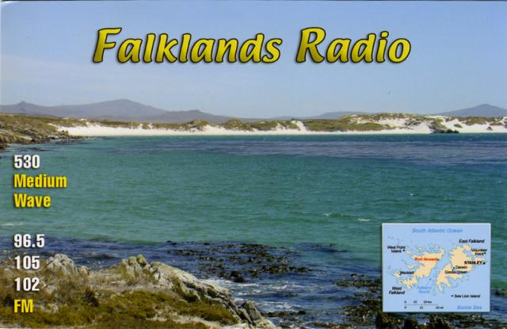

From: Corina Goss

To: Gary Deacon

Sent: Tuesday, September 01, 2009 7:12 PM

Subject: Unusual reception of Falkland Island Broadasting Service on 530 kHz in South Africa

Dear Gary,

I’m sure that would have been us re-broadcasting BBC World Service at that time of day.

I’ll put a QSL card in the post for you.

I don’t know how long it will take to reach you, but I expect will at least be 2-3 weeks.

Kind regards,

Corina

John Plimmer logs RX Icom IC-7600
antenna 350m to New York and over shoulder to Australia

Freq Time Date Country Town Station Mode Power Kw
350 325 09/08/25 BRAZIL VITORIA VTR CW 0
400 334 09/08/25 MOZAMBIQUE INHAMBANE IN CW 0
400 330 09/08/25 BRAZIL NATAL NTL CW 0
400 326 09/08/25 BRAZIL RIO DE JANEIRO CAX CAXIAS CW 0
530 501 09/08/26 FALKLANDS ISL STANLEY BBC WS RELAY ON FIRS EE MW 15 TKS GARY
540 2234 09/08/25 BRAZIL ARACUJU R JORNAL PP MW 1
550 2232 09/08/26 URUGUAY COLONIA R COLONIA SS MW 2
550 409 09/08/27 BRZ PARNALBA R GLOBO PP MW 1
600 321 09/08/25 BRAZIL PORTO ALEGRE R GAUCHA PP MW 100
612 2221 09/08/26 AUSTRALIA DAWALLINI 6RN ABC EE MW 10
666 2218 09/08/26 REUNION ST PIERRE R REUNION FF MW 20
720 1535 09/08/24 AUSTRALIA PERTH ABC EE MW 50
740 2251 09/08/26 BRZ BAHIA R SOC DA BAHIA PP MW 100
780 2318 09/08/26 BRZ EIRUNEPE R NACIONAL PP MW 10
790 358 09/08/27 ARGENTINA CAP FED R MITRE SS MW 5
800 2322 09/08/26 NETH ANTILLES BONAIRE TWR GOSPEL EE MW 100
819 1821 09/08/25 EGYPT BATRA ERTU AA MW 1000
828 1729 09/08/24 AUSTRALIA GERALDTON 6GN ABC EE MW 10
837 1847 09/08/24 INDIA VIJAYAWADA AIR VV MW 100 DANCE MUSIC
860 2332 09/08/26 BRZ RDJ R CBN PP MW 100
936 1530 09/08/26 INDIA TIRICHIRAPALLI AIR NX EE MW 100
954 1555 09/08/25 PHILIPPINES QUEZON CHRISTIAN ERA BC SVC VV MW 40 TKS VINCE 11200 KMS
990 1553 09/08/26 CYPRUS CAP GRECO BBC SPORTS EE MW 600
999 1611 09/08/26 INDONESIA JAKARTA RRI VV MW 150
1053 1620 09/08/26 INDIA TUTICORIN AIR MUSIC VV MW 200
1062 1553 09/08/25 PHILIPPINES QUEZON ETVC EAGLE CORP VV MW 40 TKS TO GARY
1100 328 09/08/26 BRZ SP R GLOBO PP MW 50
1134 1807 09/08/25 ANGOLA MULENVOS BENGO PP MW 10
1220 1 09/08/26 BRZ RDJ R GLOBO PP MW 150
1242 1551 09/08/26 VIETNAM THAI LONG CAN THO CC MW 2000
1296 1732 09/08/24 AUSTRALIA WAGIN 6RN ABC EE MW 10
1296 1639 09/08/25 AUSTRALIA WAGIN 6RN ABC EE MW 10 E100 BAREFT ALCOHOL & COMMUNITY
1323 1738 09/08/24 CHINA CRI EE MW 100
1323 2201 09/08/24 CYPRUS ZYYI BBC NX EE MW 200
1386 1629 09/08/25 CHINA CRI NEWS TEAM EE MW 50
1404 1625 09/08/25 AUSTRALIA BUSSELTON 6TAB EE MW 4 RACING
1410 322 09/08/26 BRZ SP R AMERICA PP MW 25
1413 1614 09/08/24 JAPAN FUKUOKA JOIF JJ MW 50 “ 13,600 KM “
1413 1623 09/08/23 OMAN A’SEELA BBC UK AA MW 750
1449 1614 09/08/25 AUSTRALIA MANDURAH 6TAB EE MW 2 HORSE RACE
1458 2136 09/08/26 MAYOTTE PAMANDZI RFO FF MW 5
1467 1553 09/08/24 INDIA JEYPORE AIR EE MW 100
1500 403 09/08/25 USA WASHINGTON DC WFED CNN RADIO EE MW 50
1510 359 09/08/25 USA NASHVILLE TN WLAC EE MW 50
1520 457 09/08/26 USA BUFFALO NY WWKB EE MW 50
1557 2318 09/08/25 FRANCE NICE FRANCE INFO FF MW 300
1557 1518 09/08/24 TAIWAN KOUHU WYFR GOSPEL EE MW 300
1566 1520 09/08/24 S KOREA JEJU HLAZ CC MW 250 “ 13,500 KM “
1566 2212 09/08/24 BENIN PARAKOU TWR FF MW 100 ALSO ID’ AS R ELWA
1610 2223 09/08/24 ANGUILLA THE CARIBBEAN BEACON EE MW 40 EST POWER
1670 500 09/08/25 USA DRY BRANCH GA WFSM EE MW 1 “ BILL SHANKS SHOW / FOX SPORTS 13200 KMS “
1700 350 09/08/25 USA BROWNSVILLE TX KVNS EE MW 1
3395 2300 09/08/26 INDONESIA KENDARI RRI VV SW 5
4750 2306 09/08/26 INDONESIA MAKASSAR RRI VV SW 20 //3395
8879 1511 09/08/25 SEYCHELLES SEYCHELLES WKG AIR FRANCE EE USB 10
8888 1508 09/08/25 ANGOLA LUANDA LUANDA WKG AIR ANGOLA EE USB 10
8915 1453 09/08/25 USA HONOLULU SAN FRANCISCO AIR EE USB 10 WKG JAPANAIR AT 160E
8942 1455 09/08/24 SINGAPORE SINGAPORE WKG VARIOUS EE USB 10

Vince Stevens logs

550 26082009 04h05 URUGUAY R.Colonia Colonia ID in SS good VS
594 25082009 15h00 AUSTRALIA 3WV Horsham Presumed w ABC nx //720 (only Aussie on this fqy) poor VS
630 25082009 16h02 PHILIPPINES DZMM Bulacan Possible ID (still need to check recordings), mixing w 2 other stns poor VS
630 26082009 16h00 AUSTRALIA 4QN Townsville ID as 'ABC Local Radio North Queensland' then nx poor VS
730 27082009 04h04 PARAGUAY R.Cardinal Asunción ID in SS poor VS
895 25082009 04h52 ST.KITTS/NEVIS V of Nevis Presumed w Elton John song, then soon faded out v poor VS
954 24082009 15h45 PHILIPPINES DZEM Bulacan ID & EE Gospel, also on 25/08 w ID as 'Christian Era Broadcasting' good VS
1053 25082009 18h13 JAPAN JOAR Nagoya 'All Night Nippon' ID poor VS
1134 26082009 16h11 AUSTRALIA 6CI Bunbury Ads for businesses in Bunbury poor VS
1215 26082009 16h25 AUSTRALIA 6NM Northam Presumed w Trevor Chappell Overnite prg //720 (only 400W) Under R.Botswana v poor VS
1260 26082009 16h27 AUSTRALIA 6KA Karratha slow pops, mentions of Karratha & slogans poor VS
1278 24082009 17h09 JAPAN JOFR Fukuoka in JJ w 'RKB' ID's etc.. fair VS
1332 25082009 19h06 JAPAN JOSF Nagoya Presumed w talks in JJ fair VS
1380 27082009 06h08 CHILE R.Corporación Santiago ID's & Piano mx fair VS
1431 26082009 16h55 JAPAN **UNIDENTIFIED** w 'All Night Nippon' ID (all stns are 5KW or less) v poor VS
1470 27082009 05h40 URUGUAY R.Cristal Las Piedras Presumed w Voz Cristiana Relay, the Chilean SW service originating from Miami (thanks Chuck Hutton/Henrik Klemetz for the research) poor-fair VS
1500 26082009 04h58 USA WFED Washington DC ID as 'Federal News Radio' good VS
3325 25082009 20h00 INDONESIA RRI Palangkaraya ID & usual TOH RRI signature music fair
3905 25082009 19h58 PAPUA NEW GUINEA R.New Ireland Kavieng Ads in Pidgin, then Nx in EE & Tok Pisin good

RX: Drake R8A
ANT: various Beverages & BOG's, 200-400m long


Gary Deacon and Vince Stevens


John Plimmer and wife Dawn

Gary’s huge Fostex recorder and under it his tiny shirt pocket Sony ultralight receiver
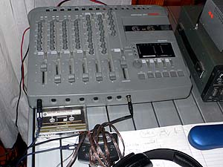

This DXpedition went quite smoothly and all went well including our arrivals and returns safely home. The weather was a bit cool and windy but that didn’t really affect us.

Our retro DXer Gary awed us by his reception of wonderful DX exclusively on his tiny little Sony ultralight radio. In the photo you can see the antenna wire wrapped around it to couple the signal. When he got Falklands on it Vince and I didn’t at first believe him, but next morning when it came in again it was verified on our bigger radio’s. Great excitement as Falklands has never before been logged on MW in South Africa.

John gave up each morning at an hour after sunrise, but Vince and Gary continued and that is when Gary patiently got Falklands and some of his best South American catches. On the last morning the reception continued to 9.00 a.m. local time (0700Z) with the sun well up in the sky.

Getting Japan in the evenings is a big thrill as it is one hellava long ways away from us, nearly 14,000 km’s.

Years ago when we first came to Jongensgat it was quite isolated and electrically very quiet. As the years have progressed more buildings have gone up some 500m away and due to power constraints the power utility has fitted cheap no name brand CFL mini fluorescents to all the buildings in the area. These kick out a huge RFI, so this trip I took along some old style incandescents that we replaced the CFL’s with. So, as you see from the logs, we did well, but electrical noise is now intruding more and more at this ideal DX site.

