Aihkiniemi 22-29 Jan 2022 (AIH151)

This article first appeared in Medium Wave News and is reproduced with permission.

About a thousand km north of Helsinki are two cabins with 14 Beverage antennae 1km long in length or more, beamed across the planet. I went there in January 2022 for a week, when the sun lingers just a few short hours above the horizon and medium-wave comes alive for virtually 24 hours a day. It is probably the best AM dx locale in the world. AM radio signals are around us all the time, in Aihkiniemi you can pick them up.

It’s a trip I’ve wanted to make for several years, so it was very exciting to team up with Martti Karimies, a founder member of the Aihki group. Martti’s profession is master builder and he’s been responsible for most of the construction at the site. We made up the 151st dxpedition there. I took a flight to Helsinki from London, another one up to Ivalo and then a car ride to the Aihki cabins, in the Arctic Circle.

I’ve quite a lot of AM dxperience, having set up several trips to Cape Point (near Cape Town, South Africa) using 300-400m Beverages (on the ground) and heard and verified many stations in the Americas, including some US AM stations 12 to 16 thousand km away. Also audible there over the years have been Indian, Australian, Filipino, Chinese, Taiwanese, Japanese, Thai and Pacific stations.

But this was in another ballpark. For one thing, Martti has heard 100s of stations from Asia and Australasia, as have other members of the Aihki group, and his language recognition for the region is outstanding, much better than mine.

The set-up is comfortable – two cabins, one housing the radio room, toilet and a bedroom/kitchen; the other, a sauna and another bedroom/kitchen. Wifi, heating, basic cooking and storage are perfectly adequate for two undemanding dxers. The sauna is lovingly designed and built, with outstanding ventilation.

The outside temperature reached a low of minus 20, not as cold as it can get, and with a low wind factor it wasn’t too hard to handle for a South African initiate. We did our fair share of snow-shovelling, following light falls on a few days. We also saw a good show of the Northern Lights one evening, which really topped off the trip.

We were lucky with the space weather. We met the two dxers from the previous week, as they were leaving, who reported disappointing conditions. Martti has done a lot of interesting work on solar proton and electron activity and his projections from the latest data pointed to improving conditions for our week. And so it turned out to be. The radio reception was scintillating, for me. For starters, the US and Canada north-west, Alaska and Hawaii are all out of reach from Cape Point but in full glory at Aihki. During my first weeks back, ploughing through my recordings (using two Winradio Excalibur Pros and a lot of external memory) I only managed to work through a few sessions and logged over 200 new stations across many US and Canadian states, Mexico, Puerto Rico and Argentina. Further listening produced many more North Americans including 20 Alaskans, 8 Hawaiians and stations from Uruguay, Colombia and Ecuador.

For the Aihki regulars hardly any of these, if any, would be new but for me there were often several new ones on the same frequency. Sure, as I go along through other recordings there will be many repeats but it was still a pleasure tracking down and identifying stations. As any dxer knows, this involves detective work using local ads, station cues and music beds, traffic info, weather, phone area codes, station formats, networks, IDs between songs etc. At Cape Point I typically record from 5 minutes before to 10 after the top of the hours but in Aihki we were running recordings uninterrupted for several hours at a time. This requires a lot of patient listening. Not that you need to listen every second but as conditions change through the hours, different stations and formats fade in and out and to get the weaker ones you need a combination of persistence and luck. For me there have been many little gems so far, along with the blockbusters and I’ve only just started on the Asian/Pacific/Australasian recordings. Towards the East so far I’ve logged over 20 Filipino’s, some Australians and a long string of Japanese and Chinese stations, only a few of which I’ve tried to identify yet.

One obvious reason for my hearing many new US stations is that many have mandated antenna patterns at night and the ones I tended to hear at Cape Point were oriented south-east. These are the same stations I’d be less likely to hear in Aihki, especially the lower-powered ones.

From past articles on Aihkiniemi in dxing.info I have seen quite a large number of NZ logs. They were hard to find on our trip but I do know that we heard at least one Kiwi station - Magic on 1107, subsequently QSLd. This was a particular thrill for me as, despite decades of trying at Cape Point and other venues around Cape Town, I never broke through to New Zealand..That afternoon Martti also heard a new Australian station (something that doesn’t happen often for him) so we celebrated with a couple of tots of Bowmore 12-year old.

We also heard Tonga. This was about 10 days after the climax of the volcanic eruption in the archipelago. I checked on my return because Gary De Bock had reported hearing A3Z from Oregon. I found a good signal on 1017 kHz one afternoon and sent Gary a brief mp3 recording and he confirmed the voices of the main male and female announcers at the station. We also heard Fiji on 990 (subsequently QSLd) and Kiribati on 1440.

I have to say that at the beginning I was quite overwhelmed by the huge range of signals available. With 14 antennae to choose from, making sure the right one is switched on, on the right receiver, needs concentration. Luckily Martti, with all his experience, was constantly calling out frequencies and stations to me as a guide to what was coming in best. Once I got the hang of it, I started trying out antenna combinations of my own to get the best signals.

Martti was running 3 Winradios, along with my 2 Winradio Excalibur Pros and for all these receivers there is a bewildering set-up of splitters and antenna switches but it all makes sense. From what I’ve been told the earthing of the antennae is very effective.

The antennae are suspended well above ground, requiring regular maintenance, especially when snow falls because any ice build-up on the wires can cause them to break. There are farmed reindeer in the area and it’s vitally important that the Aihki group prevent reindeer from getting tangled up in the cables.
For me the environment was unique - beautiful sunsets, soft wind in the pines, sun clipping the tops of trees, the occasional truck rumbling past on the 971, crunchy snow underfoot, squirrels, Siberian birds, herded reindeer, frozen lakes.

I’ve attached two clip-outs from my Excalibur Pro to show the differential noise levels between Cape Pt and Aihkiniemi. The arrows indicate that the Aihki noise floor at a similar time in the morning, around 0400 local time, was slightly lower than at Cape Pt. The latter is a quiet site with negligible electrical interference so Aihki is very special in this regard. Once you add the length, compass range and elevation of the Aihki Beverages, you’ve got the best there is.

Of course there are some US stations that pop up wherever you go, south or north e.g. WINS, KSL, WHO, XEG and the like, quite often dominating the channel. But the beauty of the long recordings and outstanding antennae is what pops out when these biggies inevitably fade from time to time.

Somewhat counter-intuitively, one of the stand-out stations I heard ‘live’ was CBC 1230 from Iqaluit in Canada. This is an Inuit station and when I heard it they were playing Texan C&W songs with Inuktitut (I believe) lyrics. Something special and unusual for me, albeit just ‘down the road’ from the Finnish Arctic Circle. DXing is not just about picking out new stations. Every now and again I was mesmerised by things like the laughing female chat on Japanese stations, arresting Taiwanese instrumental music, tango from Uruguay and the chimes of NHK1 stations signing off across the band.

On some frequencies there is an absolute cacophony of stations fading in and out. I’ve experienced similar, particularly with South American dx where 5 or 6 stations from across the continent can be duking it out at the same time. It’s easier for an English speaker like me to weed out US/Canadian stations (although a few are Spanish or Chinese) and I’ve also been learning Spanish for several years. But when it comes to Asian languages, with such long hours of recording, it’s a challenge. I find it particularly hard to pick out Chinese and Thai IDs. Luckily the Filipino’s are very obliging with their multi-lingual IDs.

All-in-all Aihki was a unique and riveting experience. Although I’m based in Oxford, England now I’m pleased to be the southern hemisphere dxer who’s tasted dx at Aihkiniemi. On my way back I was able to meet with Mika Makelainen in Helsinki, who originally kindly accepted my request to visit Aihkiniemi. He told me he has over 100 terabytes of recordings from over the years, that he hasn’t listened to yet, and has more trips planned, along with the other regulars.

ENDS

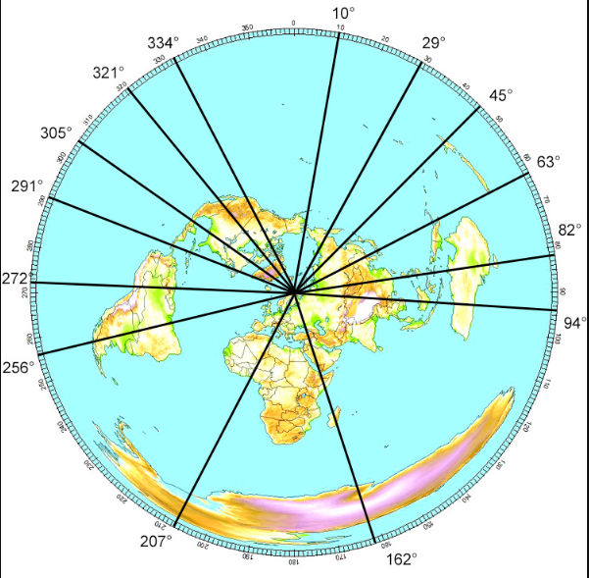

Antenna orientations.

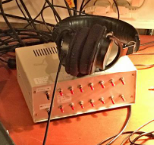

A switchbox with amplifiers and fitted for 14 antennas, made by Stefan Wikander.

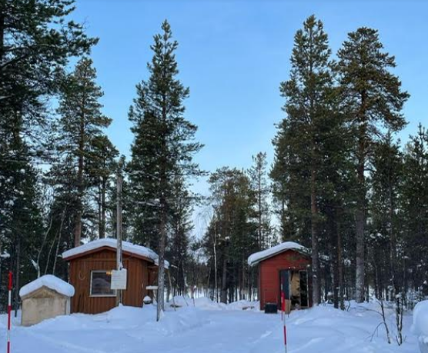

The radio room is in the cabin on the left.

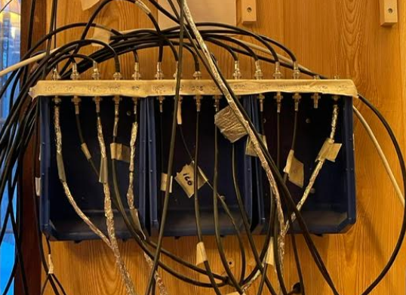

Antenna feeds.

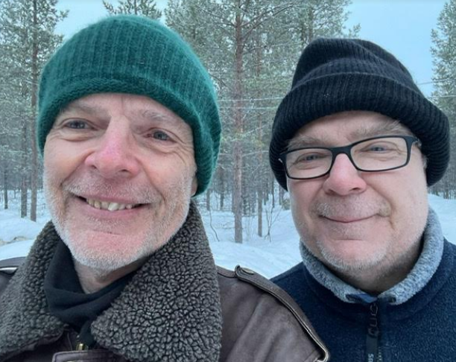

Graham (left) and Martti.

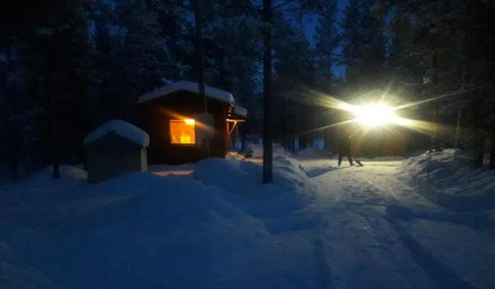

Snow shovelling in the morning.

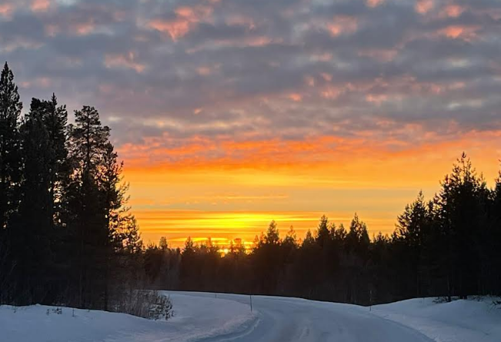

Sun setting around 2.25pm.

Aihkiniemi

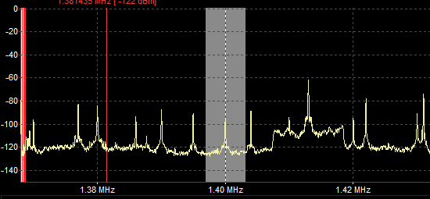

Cape Point

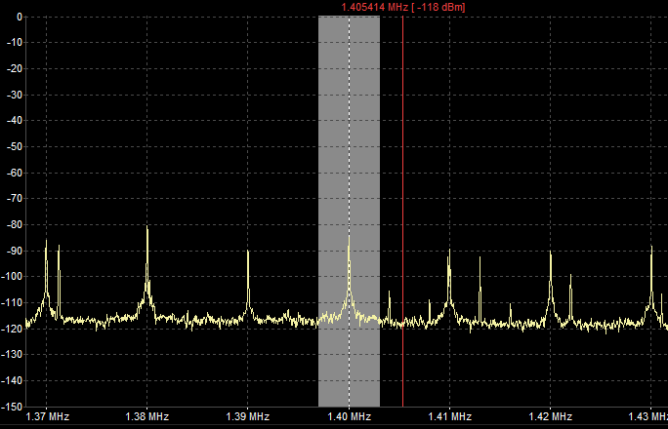

Comparing noise floors.

